
MODUL 12 PERKULIAHAN 2025
English for General Purposes
- 4 LANGUAGE SKILLS
- Grammar:
- VOCABULARY

Fakultas | Program Studi | TatapMuka | Kode MK | KELAS |   DisusunOleh  Drs. Budiantoro, MA
FEB | Program  AKUNTASI & MANAJEMEN | 12

Abstract Google is well-known for empowering students of all ages, genders, nationalities, and religions. It provides students with limitless opportunities.

Competency
Students are able to understand, first, the vocabulary by listening, speaking, reading and writing from general resources of Presenting The topics below:
- How Google Apps Play An Important Role In A Student Life
- Post navigation
- Technology And GAFE (Google Acceptance For Education)
- Understanding Role Of Google Apps In Education
- Adoption Of GAFE By Universities

- Role Of GAFE Or Google Apps In Students Life
- Empowering students
- Inadequate selection
- Communication
- Enhance Productivity
- What is your own conclusion?

How Google Apps Play An Important Role In A Student Life

Post navigation
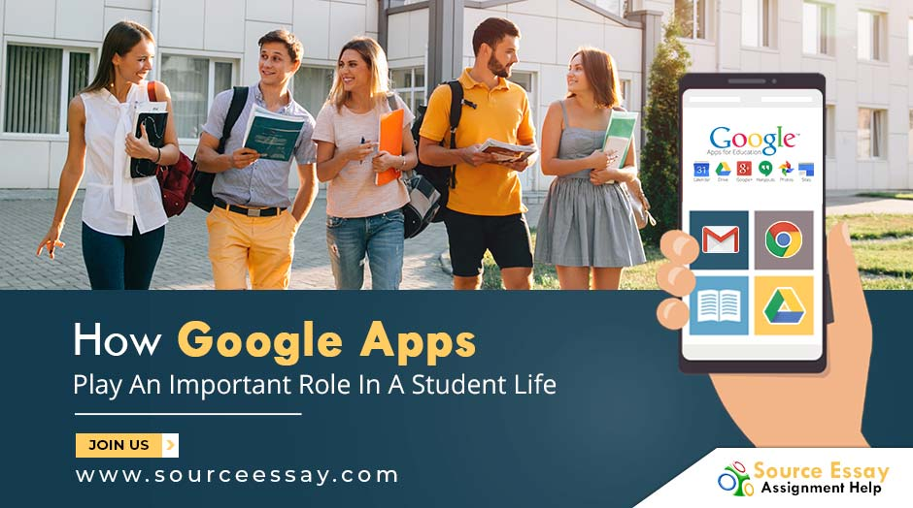
Share
Google has become a widely accepted search engine platform since its inception in 1998. It has transformed the way we study, take every challenge and embracing a variety of practices for innovation.
With the rapid development and educational apps accessibility, there has been a significant change is seen in adopting apps by educators also one who use these apps. Currently, a spectrum of competing apps is present in the market including iOs Apps, google apps, One drive apps, Chrome books etc. Most of the apps allow navigation of content with taps, finger zooms, or finger swipes.
Over the years, significant growth has been seen in Google apps installation and utilization shared documents, drives, video aiming of transforming learning and teaching altogether. According to the Babson survey, several students who is pursuing at least one course online increased by 7.1% since 2013-2014. This number was subsequently increased by 48.1% in 2018-2019 (Wallis, 2020).
Presently Google Apps has more than 40 million online tutors, teachers’ faculty members, students and staff members. In accordance Brishtitechnology report, out of 100 American Universities, more than 70 universities are using Google Apps. Also among eight Ivy League universities are known for using Google Apps. The purpose of this article is to cover several aspects of Google apps contributing to huge success in the academic world.

Technology And GAFE (Google Acceptance For Education)
Social media networking apps have shown drastically change in this highly competitive world. Gewerc, Montero, and Lama (2014) inferred from the study social media platforms offers numerous opportunities for collaboration and visibility among students. They said, when social media used by teachers and learners in a classroom, this will create an interactive learning environment.
As per assignment writer Bristol, when an app designed for pedagogically usages, it tends to provide a bridge between the gap formed between education and technology with exclusives drive of advance learning platform to the school. From the above statement, we can define GAFE as integrated based cloud suite aiming to transform the 21st-century education system.
All the google apps were formed to support provisioning of Google Suite and other collaborative tools such as Google+, Google Documents, Google Sheets, Google Meet, Gmail, Google Chats, Youtube Etc.
To meet the drastic change due to Covid-19 applicability of Google learning apps have been seen as instrumental regardless of geographical locations. Besides these statistics, some online learning platforms such as MOOCs having a primary objective to make education is available for potential learners enables universities to teach students of diverse background (Awuah, 2015)
In case you find it difficult to understand the role MOOCs on a broad perspective for your assignment writing, take guidance from SourceEssay based essay writer team right now.

Understanding Role Of Google Apps In Education
GAFE is most power cloud-integrated platform works no matter where students live or using its devices (Google, 2013). This platform enables thousands of students to access the quality of education with collaborative tools with a primary focus of enhancing the traditional way of teaching and learning. Google apps and tools enable faculties and students to work in nexus virtually on documents, reports, presentation and projects. This predominately helps in making cloud-based websites complement to traditional instruction for delivering an effective course in less time.
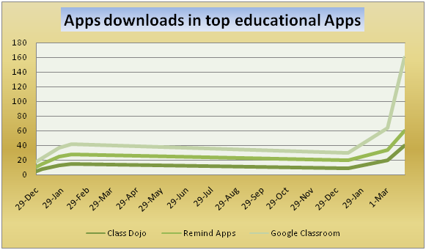
Source- App Annie
In an outlook of Schaffhauser 2020, percentage of the download of educational apps increases every week by 90% till the initial and ending months of 2019 and 2020. Only in the United States, the top educational apps are found to be Google classroom, class dojo, Remind Apps- Safe classroom apps for sharing videos conducting lectures and providing a message, Google Classroom has topped among the survey and registered 60% growth in app downloading that is expected to grow by 150% in upcoming months.
As per online assignment help experts, this growth is achievable only because unique features Google tries to deliver every time and making learning more effective. In addition to this, most popular Google suite such as Gmail, Google Calendar, Google Docs, Google Groups Google+ Google Sites, and Google Drive have been developed having specifically targeting business and education.

Adoption Of GAFE By Universities
It is evident and been in news from past decades, US universities have partnered with Google to make sure GAFE platform suitably offers faculties and students predominant ways to conquer challenges in rapid globalization and technological advancements. For instance, Arizona State University is determined to allow technologies in education space to rebuild thinking and new methods of teaching.
Apart from the customized mode of Google Documents, Google spreadsheet allows tutors to share sheet and thus evaluating students’ performance on a solid basis. All the UG universities are continually sourcing technologies and adapting them to gain online experiences and effectively enhancing teaching and learning.
Some other universities like Valparaiso University are transitioning google apps in group-wise email and calendar. There is no doubt, these steps significantly impacting the way learning perceived. With these clouds, based solution teachers get massive supports and thus enhancing productivity.
But some essay helper Perth said the adoption of G Suite can be quite challenging at times. A study has revealed some innovation might get failed if users fail to apprehend challenges. If you want to know reoccurring challenges Google apps have been facing since the long period, then Source Essay based essay rewriter team are always ready to provide ample information on a variety of issues for your assignment writing.

Role Of GAFE Or Google Apps In Students Life
The adoption of Google apps allows various groups to share contents via Wikis, Google docs Google forums and Google Sheet. A typical example is how students use Goggle Forums to conduct a survey, facilitates ease of collaboration and drawing statistics to draws conclusion. Users gain the ability to add calendar entries directly from the G mail accounts. Let’s move ahead to explore the critical role Google plays in students’ life-

Empowering students
Google is widely recognizable for empowering students irrespective of their age, gender, nationality and religion. It provides students with limitless opportunities to explore varieties of topics and gives them equal advantages to access the information. GAFE tools are powerful and easy to apprehend by managers simultaneously give access to students to all the change in different time stamps.

Inadequate selection
Google offers a great range of choice for both educators and learners in terms of computability with reading materials. Google apps provide revision history so that students can see all the changes at one go or if they are available during teaching hours, they can access lecture in their free time (Sudarsana, 2019)

Communication
Google Apps facilitates both communication and collaboration in order to achieve optimum productivity in a limited period. For instance, GAFE-based course websites students will be updating their knowledge and can see their assessments procedure. They can also take help from assignment help experts assistance from Google meet if they find any difficulty in writing assignments.

Enhance Productivity
Last but not the least Google apps have been able to penetrate deep in the education system irrespective boundaries because it provides free services for students or sometimes very cheap. Its educational devices are affordable and easy to maintain at the same time it is supported by the best talent pool in the world.

Conclusion
We have started this blog by signifying how Google has achieved massive success over some time and penetrating deep into the educational sphere. There we extracted a significant growth has been seen in Google apps installation and utilization for sharing documents, drives, video aiming of transforming learning and teaching altogether. In the next section, we have tried to present a shred of evidence to highlight the growing rate of GAFE adoption in the education system by sourcing statistics adopted from Annie source. Later on, we determined how many universities in American are emphasizing on Google apps or partnered with the company to make learning dynamic and interactive. At last in the blog, we have discussed the role of Google Play in education by illustrating key points such as of Google apps allows various groups to share contents via Wikis, Google docs Google forums and Google Sheet also it facilitates both communication and collaboration in order to achieve optimum productivity in the limited time span
- Essay Questions (10 Items)
- Explain how Google Apps empower students in the learning process according to the module.
- Describe the role of GAFE (Google Acceptance for Education) in transforming 21st-century education.
- Based on the text, discuss how online learning apps grew significantly between 2019 and 2020.
- How do Google Apps enhance communication and collaboration between students and teachers?
- Describe two challenges universities might face when adopting G Suite for education.
- Explain the function of revision history in Google Apps and why it is beneficial for students.
- Discuss how MOOCs support accessibility in global education based on the module.
- Summarize the importance of cloud-based collaboration tools such as Google Docs and Google Sheets.
- Based on the passage, analyze why Google Classroom became the top educational app in the United States.
- Based on the conclusion of the text, explain the overall impact of Google Apps on modern education.

- Multiple-Choice Questions (35 Items)
(Choose a, b, c, d, or e)

Grammar & Structure (1–10)
- Google Apps ___ students to collaborate online.
a. enabling
b. enables
c. enable
d. is enable
e. was enabled
- The number of students taking online courses ___ rapidly since 2013.
a. increase
b. increases
c. has increased
d. have increased
e. increasing
- Many universities ___ Google Apps to support teaching and learning.
a. adopt
b. is adopting
c. was adopting
d. are adopted
e. were adopt
- Social media platforms ___ opportunities for collaboration.
a. provide
b. provides
c. providing
d. provided
e. is provided
- Google Classroom ___ by millions of teachers during the pandemic.
a. use
b. was used
c. using
d. uses
e. is using
- Students can access lectures ___ they are not present in class.
a. because
b. although
c. if
d. unless
e. while
- GAFE tools help teachers evaluate students’ work ___ sharing documents.
a. by
b. from
c. on
d. about
e. for
- The adoption of Google Apps is challenging ___ some users cannot adapt to new technology.
a. so
b. because
c. although
d. despite
e. unless
- Google Apps were created ___ support collaboration.
a. to
b. for
c. at
d. with
e. by
- The report shows that app downloads increased ___ 90% in early 2020.
a. on
b. in
c. at
d. by
e. from

Vocabulary (11–20)
- The word empowering in the text is closest in meaning to:
a. limiting
b. supporting
c. confusing
d. reducing
e. ignoring
- Collaboration refers to:
a. working alone
b. competing with others
c. working together
d. arguing
e. separating ideas
- Utilization means:
a. the act of using
b. the act of deleting
c. the act of copying
d. the act of hiding
e. the act of stopping
- Pedagogically relates to:
a. transportation
b. weather
c. teaching methods
d. business models
e. technology hardware
- Accessibility means:
a. being difficult to reach
b. being easy to access
c. being expensive
d. being hidden
e. being unimportant
- Enhance means to:
a. reduce
b. decrease
c. improve
d. ignore
e. delay
- Adoption refers to the act of:
a. rejecting something
b. starting to use something
c. selling something
d. moving something
e. replacing something
- Productivity means the ability to:
a. waste time
b. avoid work
c. produce results efficiently
d. create problems
e. delay progress
- A suite in software refers to a:
a. single tool
b. group of related programs
c. computer virus
d. website
e. hardware device
- Interactive means:
a. not responsive
b. one-way communication
c. involving active participation
d. unrelated
e. unconnected

Reading Comprehension (21–35)
- According to the module, Google was founded in:
a. 1996
b. 1998
c. 2000
d. 2002
e. 2005
- The Babson survey mentioned that online students increased by:
a. 2%
b. 5%
c. 7.1%
d. 10%
e. 15%
- How many online tutors and students currently use Google Apps?
a. 1 million
b. 5 million
c. 20 million
d. 40 million
e. 100 million
- How many American universities out of 100 use Google Apps?
a. 20
b. 30
c. 40
d. 70
e. 90
- Which platform became the top educational app in 2020?
a. OneDrive
b. Safari
c. Google Classroom
d. Dropbox
e. WhatsApp
- What is GAFE primarily described as?
a. A gaming platform
b. A cloud-integrated suite
c. A financial program
d. A hardware tool
e. A social media app
- According to the text, MOOCs aim to:
a. restrict education
b. make education expensive
c. make education more available
d. remove online learning
e. limit access to technology
- Which university is mentioned as partnering with Google?
a. Harvard University
b. Oxford University
c. Arizona State University
d. Stanford University
e. Cambridge University
- Google Forums help students:
a. play games
b. conduct surveys
c. delete documents
d. avoid collaboration
e. restrict communication
- Revision history allows students to:
a. hide changes
b. see previous edits
c. delete their instructors
d. limit productivity
e. remove feedback
- Google Apps are popular partly because they are:
a. very expensive
b. difficult to maintain
c. free or affordable
d. unavailable to students
e. used only offline
- The text states that educational app downloads increased by:
a. 20%
b. 40%
c. 60%
d. 90%
e. 120%
- Google Suite includes the following except:
a. Google Docs
b. Google Sheets
c. Google Drive
d. Google Surgery
e. Google Calendar
- The purpose of using cloud-based tools is to:
a. slow down learning
b. restrict communication
c. enhance collaboration and productivity
d. stop online teaching
e. increase classroom isolation
- The conclusion of the text emphasizes that Google Apps have:
a. decreased learning opportunities
b. made education less innovative
c. significantly transformed learning
d. replaced all teachers
e. eliminated classroom interaction

- ANSWER KEY

Essay Answers (Open-ended)
(Answers will vary but should include points from the module)
- Google empowers students by providing equal access, collaboration tools, and opportunities to explore information.
- GAFE transforms education by integrating cloud-based tools enabling virtual collaboration.
- App downloads increased sharply (up to 90%) due to remote learning needs.
- Google Apps support communication via Google Meet, Gmail, shared documents, etc.
- Challenges include user resistance and difficulty adapting to new technologies.
- Revision history helps students track changes and monitor progress.
- MOOCs make high-quality education accessible globally.
- Tools like Google Docs enable multi-user editing and faster project completion.
- Google Classroom grew due to ease of use, accessibility, and pandemic needs.
- Google Apps significantly improved access, collaboration, and productivity in education.

Multiple-Choice Answer Key
- c
- c
- a
- a
- b
- c
- a
- b
- a
- d
- b
- c
- a
- c
- b
- c
- b
- c
- b
- c
- b
- c
- d
- d
- c
- b
- c
- c
- b
- b
- c
- d
- d
- c
- c

